**Middleware**

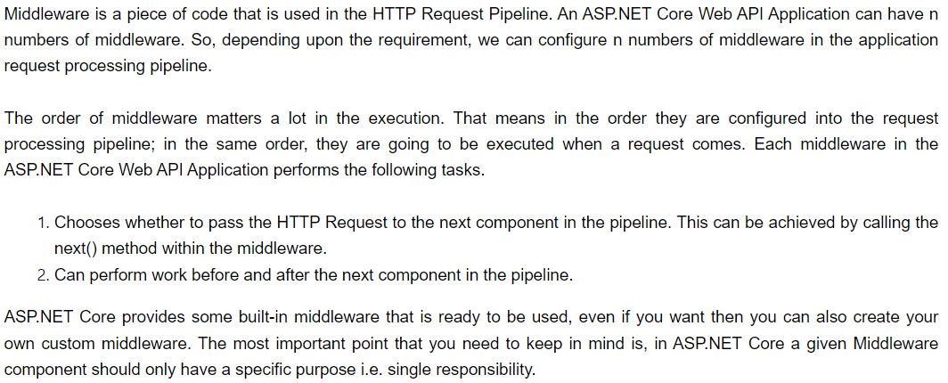

Ex:

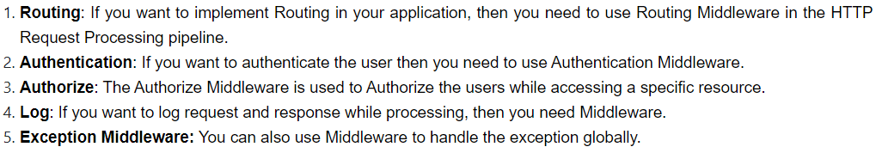



**Methods in Middleware:**

